**LAPORAN PRAKTIKUM PENGOLAHAN CITRA DIGITAL**

**3. LOGIC OPERATIONS AND REGION OF INTEREST**

**PROCESSING**



**Disusun oleh :**

**Nama :Felix**

**NPM :2327250059**

**Kelas : IF41**

**PROGRAM STUDI INFORMATIKA**

**FAKULTAS ILMU KOMPUTER DAN REKAYASA**

**UNIVERSITAS MULTI DATA PALEMBANG**

**2024**

**TUTORIAL 3. LOGIC OPERATIONS AND REGION OF INTEREST**

**PROCESSING**

**Goal**

The goal of this tutorial is to learn how to perform logic operations on images.

**Objectives**

* Explore the roipoly function to generate image masks.
* Learn how to logically AND two images using the bitand function.
* Learn how to logically OR two images using the bitor function.
* Learn how to obtain the negative of an image using the bitcmp function.
* Learn how to logically XOR two images using the bitxor function.

**What You Will Need**

* lindsay.tif
* cameraman2.tif

**Procedure**

Logic operators are often used for image masking. We will use the roipoly function to create the image mask. Once we have a mask, we will use it to perform logic operations on the selected image.

1. Use the MATLAB help system to learn how to use the roipoly function when only an image is supplied as a parameter.

**Question 1** How do we add points to the polygon?

|  |  |
| --- | --- |
| sebelum |  |
| Sesudah |  |

**Question 2** How do we delete points from the polygon?

|  |  |
| --- | --- |
|  |  |

**Question 3** How do we end the process of creating a polygon?

|  |
| --- |
| Menghubungkan Kembali ke nilai awal, atau sampai di 1 titik sebelum titik awal. |

1. Use the roipoly function to generate a mask for the pout image.



|  |  |
| --- | --- |
|  |  |

**Question 4** What class is the variable bw?

|  |
| --- |
| Sebenarnya tidak harus di beri nama variable-nya bw, akan tetapi di anjurkan atau sudah seperti kebiasaan para programmer bw berarti b(binary) w(white-black) seperti penamaan pada variable java menggunakan camelcase. |

**Question 5** What does the variable bw represent?

|  |
| --- |
| bw berarti b(binary) w(white-black). |

Logic functions operate at the bit level; that is, the bits of each image pixel are compared individually, and the new bit is calculated based on the operator we are using (AND, OR, or XOR). This means that we can compare only two images that have the same number of bits per pixel as well as equivalent dimensions. In order for us to use the bw image in any logical calculation, we must ensure that it consists of the same number of bits as the original image. Because the bw image already has the correct number of rows and columns, we need to convert only the image to uint8, so that each pixel is represented by 8 bits.

1. Convert the mask image to class uint8.



|  |  |
| --- | --- |
|  |  |
| Modifikasi kode |  |

**Question 6** In the above conversion step, what would happen if we used the im2uint8 function to convert the bw image as opposed to just using uint8(bw)? (Hint: after conversion, check what is the maximum value of the image bw2.)

1. Use the bitand function to compute the logic AND between the original image and the new mask image.



|  |  |
| --- | --- |
|  | Error using bitand  Inputs must have the same size. |

**Question 7** What happens when we logically AND the two images?

|  |
| --- |
| Error Inputs must have the same size, karena ukuran kedua gambar berbeda. |

To see how to OR two images, we must first visit the bitcmp function, which is used for complementing image bits (NOT).

1. Use the bitcmp function to generate a complemented version of the bw2 mask.

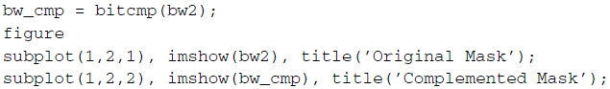

**Question 8** What happened when we complemented the bw2 image?

|  |  |
| --- | --- |
|  |  |
| Hasilnya pada original menjadi warna putih sedangkan yang complemented mask menjadi warna hitam. | |

We can now use the complemented mask in conjunction with bitor.

1. Use bitor to compute the logic OR between the original image and the complemented mask.



|  |  |
| --- | --- |
|  |  |

**Question 9** Why did we need to complement the mask? What would have happened if we used the original mask to perform the OR operation?

|  |  |
| --- | --- |
|  |  |
|  |  |
| Alasan kita perlu melengkapi masker adalah agar menampilkan gambar yang di terima dari bw_cmp. Dan jika menggunakan bw2 (original mask) akan menghasilkan atau menampilkan area yang di roipoly tadi menjadi warna putih, dan disekitarnya gambar. Dan menggunakan bw_cmp(Complemented  Mask) maka sebaliknya pada area yang di rioploy yang ada gambarnya dan sekitarnya menjadi warna putih. | |

The IPT also includes function imcomplement, which performs the same operation as the bitcmp function, complementing the image. The function imcomplement allows input images to be binary, grayscale, or RGB, whereas bitcmp requires that the image be an array of unsigned integers.

1. Complement an image using the imcomplement function.



|  |  |
| --- | --- |
|  |  |

**Question 10** How can we check to see that the bw_cmp2 image is the same as the bw_cmp image?

|  |  |
| --- | --- |
|  |  |
| Dapat dilihat hasilnya satu artinya benar/ true, bila nol maka tidak sama/ false. | |

The XOR operation is commonly used for finding differences between two images.

1. Close all open figures and clear all workspace variables.
2. Use the bitxor function to find the difference between two images.

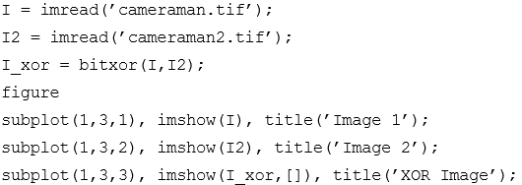

|  |  |
| --- | --- |
|  |  |

Logic operators are often combined to achieve a particular task. In next steps, we will use all the logic operators discussed previously to darken an image only within a region of interest.

1. Close all open figures and clear all workspace variables.
2. Read in image and calculate an adjusted image that is darker using the imdivide function.



|  |  |
| --- | --- |
|  |  |

1. Generate a mask by creating a region of interest polygon.



|  |  |
| --- | --- |
|  |  |

1. Use logic operators to show the darker image only within the region of interest, while displaying the original image elsewhere.

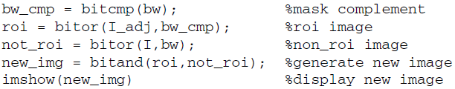

|  |  |
| --- | --- |
|  | Error code:  Error using bitor  Inputs must have the same size. DLL. |

**Question 11** How could we modify the above code to display the original image within the region of interest and the darker image elsewhere?

|  |  |
| --- | --- |
|  |  |
| Dari yang saya dapat dapat dilihat hasil dari roiploy, dan sekitar roiploy tetap terlihat, bedanya darea yang diroiploy terlihat sedikit lebih gelap. | |